Assignment 5: Observe memory allocation –best fit algorithm using OS simulator and comments on the results for the below process details.
Process Id | Memory Size
P1 | 15
P2 | 25
P3 | 20

Ans.
- Step First:
-Add the all given processes into OS simulator.
P4=15, P5=25, P6=20
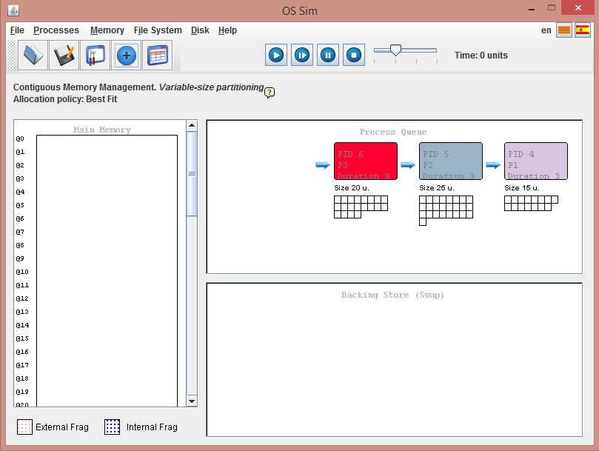

- Step Second:
-After assigning the process we will start executing them.
-Algorithm: Best Fit, Variable Portioning.
-Here space has been allocated for P4.
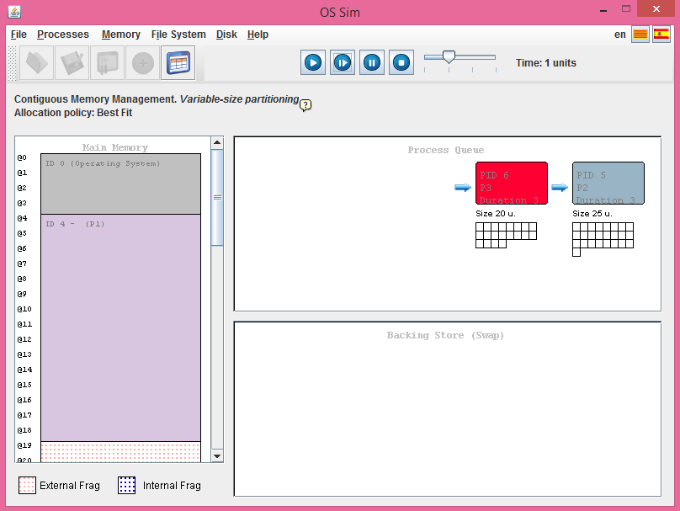

- Step Third:
-For the next the space will be allocated as with the ‘Best Fit’.
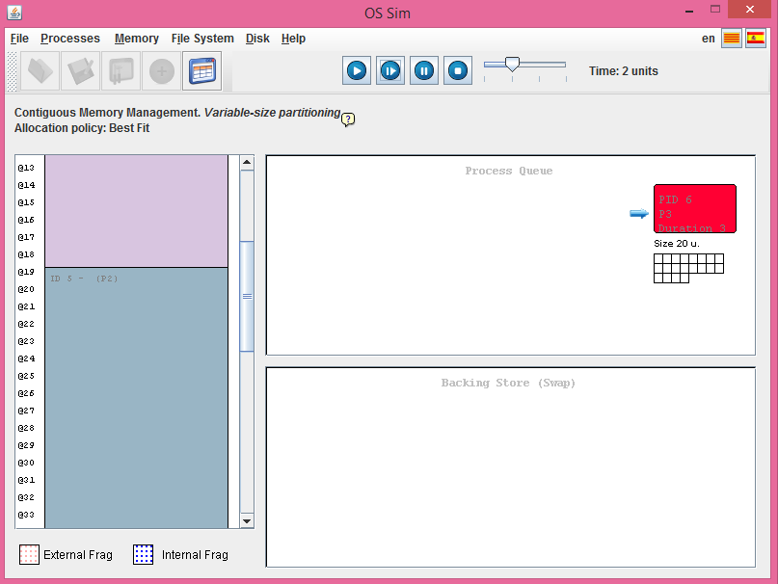

- For the next/ last step:
-The process p6 will accommodate the space as mentioned into the question.
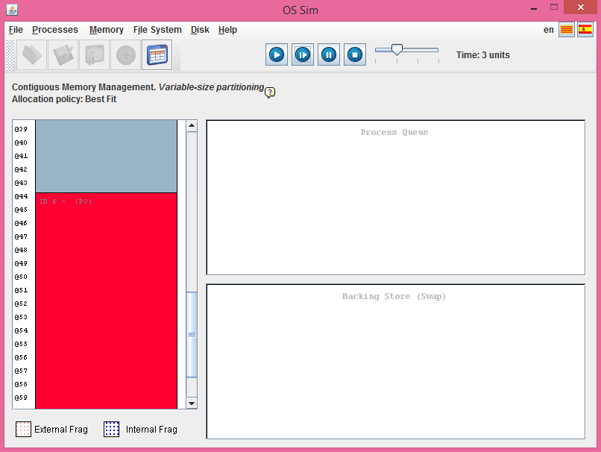

External Frag: 0, Internal Frag: 0
Settings:
-Memory Size : 64
-OS Size : 4
-Memory Management : Variable Size
-Allocation Policy : Best Fit

Occupation Report:
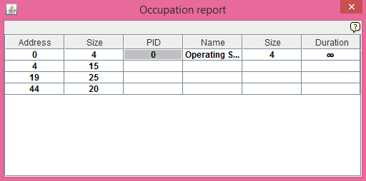
Assignment 6: Observe file management –linked allocation using OS simulator and record FAT table entries.
Ans.
Here,
Block Size (Units) : 1, Memory Size (1024 Units): 4
Allocation Method: Linked Allocation File-allocation table (FAT)
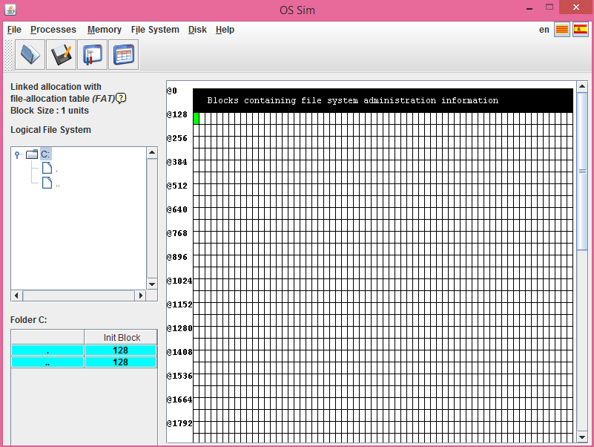
Here as displayed,
Block 128 has been containing file system administration information.
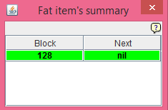
Fat item’s summary:

-Fat Table:
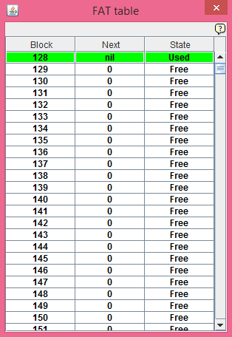
Here, this table is showing of the all information about the file system management’ occupied memory.
Example:
- Blocks showing the occupied space:
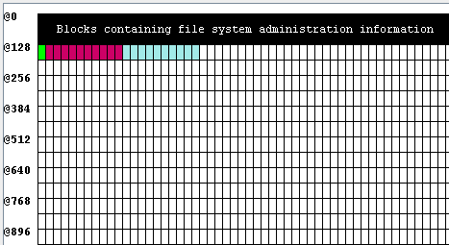

- Fat Table is showing the total occupied space:
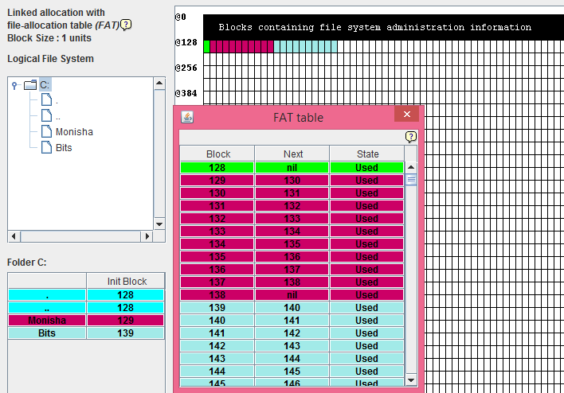

Monisha named file is occupying space : 10
Bits file occupying space is : 10

Fat Item’s Summary:
-Showing the Block and the Next block number/detail.
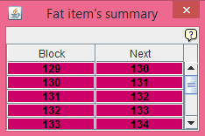

Total space occupied from @128 to @148.

